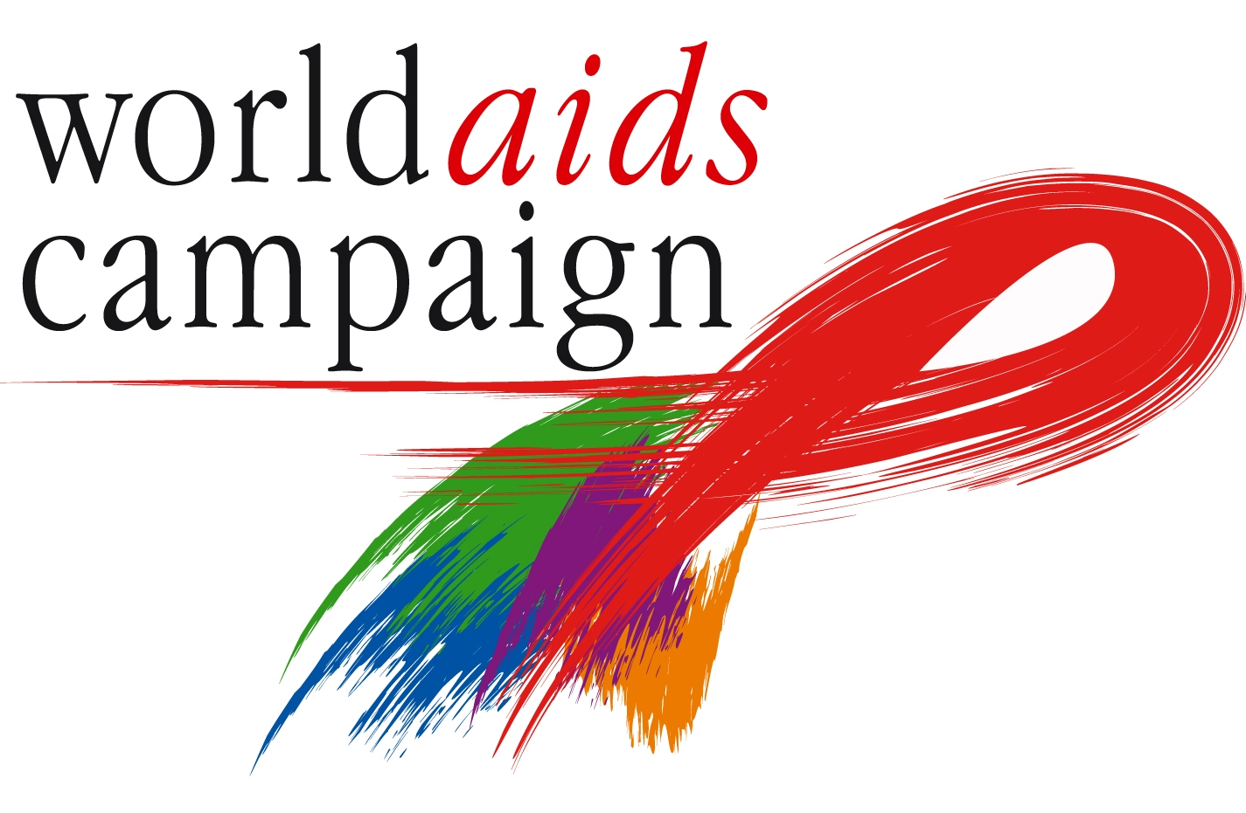

The World AIDS Campaign would like to express its’ gratitude and thanks for your assistance in making our World AIDS Day event a great success.

The day itself appropriately started with learners and the community going for VCT, followed by an upbeat march through the community attended by most of the 1500 students. That launched the driving theme for the event – direct, straightforward messages such as “get tested”, “take precautions”, “if it all goes wrong HIV is not a death sentence” – delivered by young leaders themselves, teen pop icons (Ringo, a nationwide sensation, came and performed all for an air fare from Johannesburg) and the Chair of the South African Parliament’s Health Portfolio Committee, Dr Bevan Gocqwana (from the Eastern Cape), who spoke of the urgent need for scaling up treatment and prevention.

The music and performance took over, and that is what the young people will remember. Around 250 photographs generated by the project were on display; they were a mix of images of service providers, images of people living in the community, some with HIV; and reminders of the extent to which the basic rights – to clean water, to a health environment, to adequate housing and sanitation - have yet to be delivered in this city. And a reminder of why, if Cape Town was a country, it would be in the top twenty worldwide for the number of people with HIV, which it contains.

Thank you for your assistance in making this day a great success and we hope that we can work together in future.

Best wishes,

